You Chose This
A level-based interactive word-selection installation - an experiment in what you value in life

Zeynep Zilan Turunç
Pelin Umur

- Concept

You Chose This is a level-based interactive installation that turns a participant’s instinctive choices into a generative artwork. A field of words appear on screen across five levels. Using a physical joystick, the participant moves a cursor and selects the single word they find most valuable at each moment. Early levels offer broad, surface vocabulary; as the levels advance, the words grow more personal and psychologically loaded, quietly raising the intimacy of every decision. The five levels move from Simple Pleasures, What Matters Most, Experiences & Feelings, Moments & Turning Points to Specific Memories in order.

The system never judges or scores. It observes how selections shift under repetition, how hesitation or speed reveals something the participant may not consciously notice. Each word belongs to a colour-coded thematic category, and the speed of each decision modulates the saturation and spread of a watercolour bloom. The full composition is built silently, hidden throughout play, and revealed only at the very end, confronting the participant with the picture their instincts collectively drew. The piece sits at the intersection of interactive art, behavioural observation, and generative image-making. Its central question is simple: if your choices made a picture, what would it look like? The result is abstract, unrepeatable, and entirely the participant’s own.

- Interaction Design

The participant stands before a screen where words are placed across the full canvas using a collision-free random layout, with a visible cursor resting on one word at a time. Using the physical joystick, the participant nudges the cursor directionally; the system selects the nearest word in that direction. Pressing the joystick button selects the currently highlighted word.

The interaction is exploratory rather than goal-directed: there is no score, no timer pressure, and no correct answer. Each level instead introduces a subtle urgency through increasing vocabulary intimacy. The moment of choice is kept short. Participants are not penalised for skipping a word, but the accumulating composition rewards engagement.

Decision speed operates as a silent second layer. Reaction time is measured from the instant a word layout appears to the moment of selection: faster responses produce tighter, more saturated blooms, while slower responses produce wider, more diffuse marks. The participant is never told this mapping during play and it operates below conscious strategy, so the final image records not only what was chosen but how it was chosen. Only afterwards can the participant open a “Your Choices” summary that surfaces the hidden layer: each level’s chosen prompt, its reaction time, a speed label (considered, slow, deliberate), and the resulting bloom character.
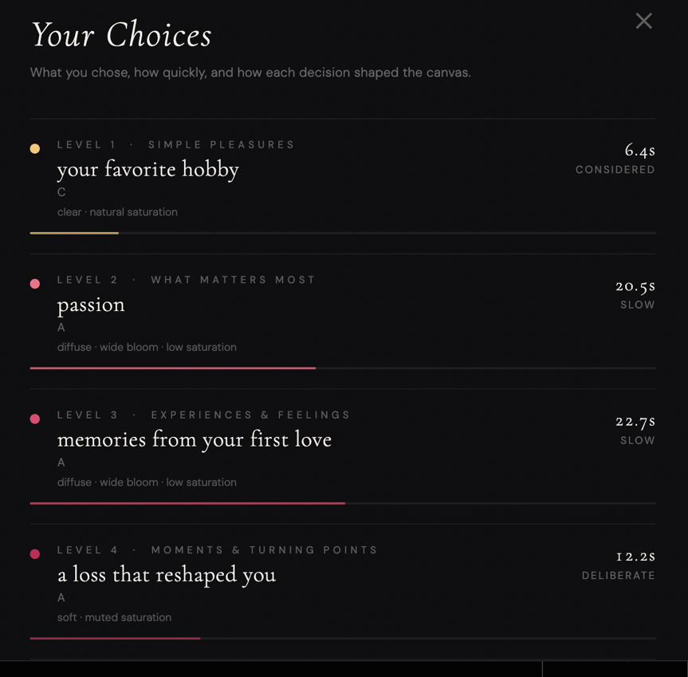

The post-play “Your Choices” summary showing the chosen prompt, reaction time, speed label, and bloom character per level. The full record can be exported as JSON.

- Input / Output System

The project relies on a four-stage pipeline running from a physical joystick to a browser rendered on a Raspberry Pi 5. Signal chain: Joystick → Arduino Uno (USB serial) → Node.js server on the Raspberry Pi 5 → WebSocket broadcast → browser canvas. The browser maintains two canvas layers: a visible game layer and a hidden artwork layer. Each selection stamps a watercolour rosette using a multiply blend mode, with radius and saturation set by reaction time. The artwork layer is composited to screen only on the final reveal.
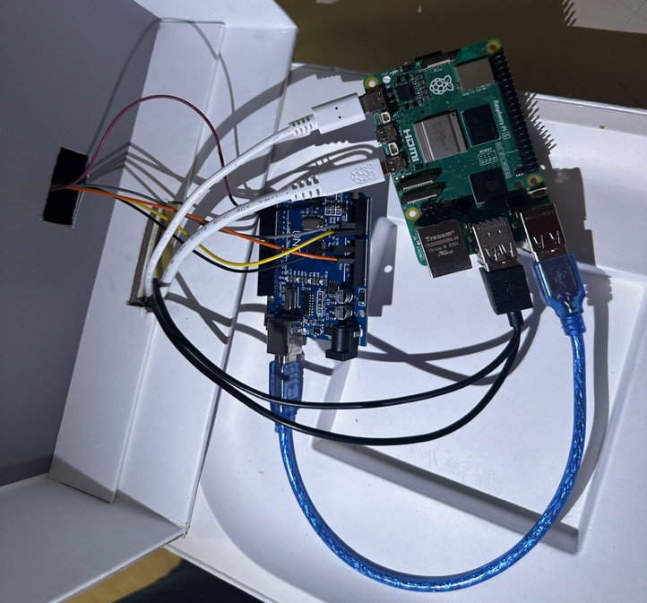
Software:
Node.js with a WebSocket server (server.js)
HTML5 Canvas + JavaScript for the game and
Generative layers
Arduino IDE (C/C++) for the joystick firmware

Hardware:
Raspberry Pi 5 (host + display)
Arduino Uno (serial middleman)
KY-023 analog joystick module

Communication:
The Arduino continuously reads the joystick’s analog X/Y values and button state and emits discrete events over USB serial. The Node.js server on the Pi parses these events and broadcasts them over WebSocket to the fullscreen browser client, which runs the navigation, selection, and generative-canvas logic in real time. This pipeline keeps cursor movement and selection responsive while the hidden artwork accumulates in the background.

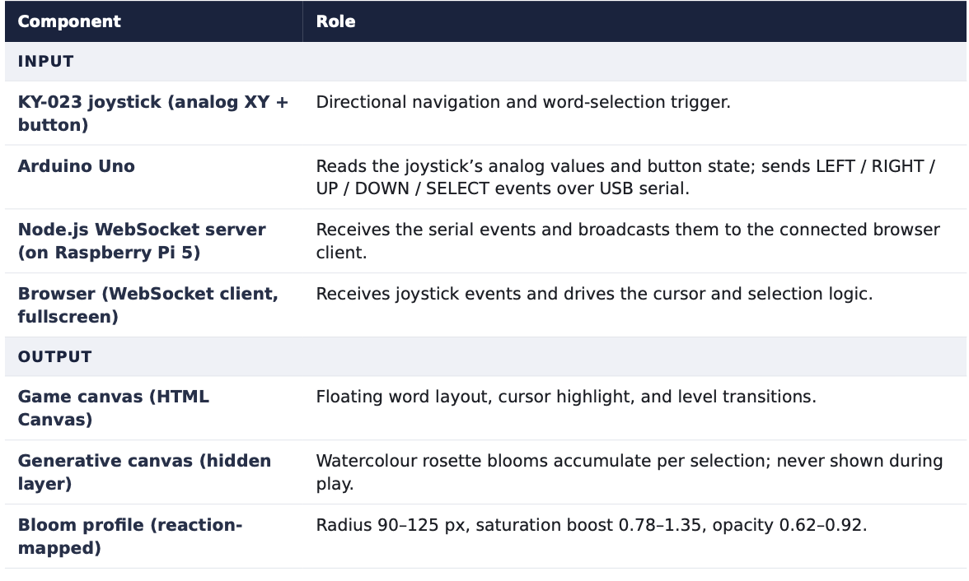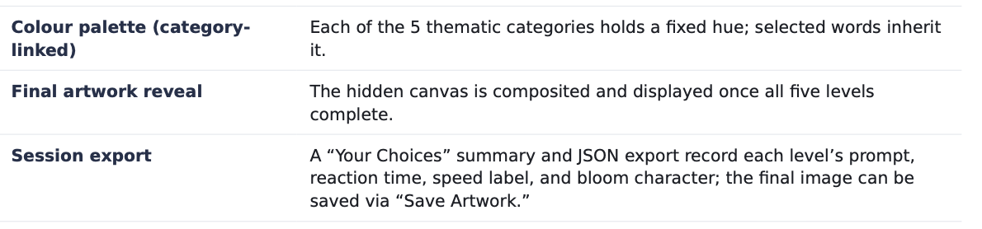
- Form & Material

Components: Raspberry Pi 5, Arduino Uno, KY-023 analog joystick module, USB cable, local Node.js server, fullscreen browser, external monitor, and a hand-built collaged enclosure with a felt-topped joystick mount.

The screen presents a dark, minimal interface. Words are laid out across the full canvas in a clean typeface, and the visual hierarchy is deliberately flattened every word appears at the same, so no typographic cue can bias a selection. The joystick is housed in a hand-built enclosure. The box is covered in newspaper and clipped photographs of a birthday cake crowded with lit candles, a backyard gathering from of empty folding chairs, children in graduation gowns, view from the backseat of a car ride. A black felt panel set into the lid holds the joystick itself.

The participant’s hand rests on a surface of accumulated memory while deciding what they value. The collage is intentional and it is meant to evoke the feelings, days, and moments that mattered to people, so that the act of choosing feels like sorting through a life rather than operating a machine.

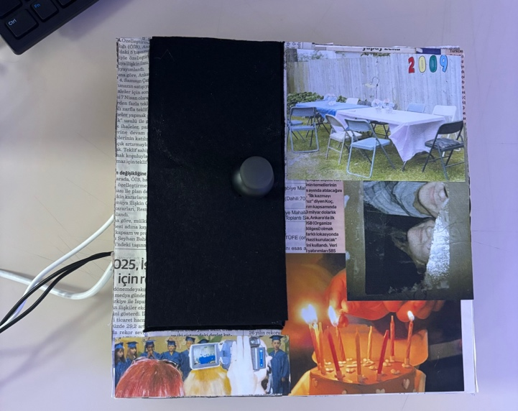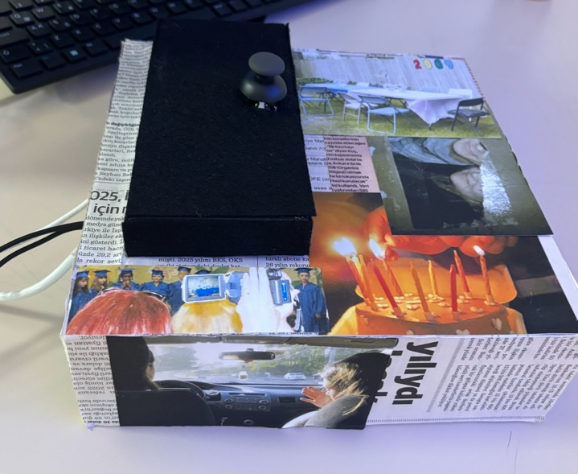

The joystick controller: a collaged box of newspaper and nostalgic photographs, joystick mounted on a black felt panel.Top view. Fragments of birthdays, graduations and ordinary days surround the single point of interaction.

The generative output uses an ebru-inspired watercolour aesthetic: layered concentric rings with randomised offsets simulate ink bleeding on wet paper. Blooms stack naturally under multiply blending, building density where categories recur. The composition stays abstract: no labels, no legible data. So the participant cannot reverse-engineer their choices from the image.

- User Experience Scenario

At the exhibition, a visitor approached the screen with the title displayed, followed by a single instruction to begin. Words scattered across the dark canvas, broad and almost casual at first, as Level 1 · Simple Pleasures asked after small things like a favourite hobby. The visitor rested a hand on the collaged controller, nudged the joystick to send the cursor to the nearest word, and pressed to select. Early choices came quickly, almost playfully. By the later levels the prompts had turned inward: passion, memories from your first love, a loss that reshaped you. And the visitor began to pause, lingering twenty seconds on one screen and twelve deliberate seconds on another. Some words passed without being chosen. They could not always say why they chose what they chose, and the controller’s collage of birthdays, graduations and half remembered days stayed under their hand the entire time. When the final level ended, the screen settled into a soft transition, and then revealed for the first time the artwork their choices had silently built appeared: an abstract field of bloomed colour, dense where their instincts had returned again and again, unique and impossible to reproduce. The session was documented in a short gameplay video recorded during the exhibition.
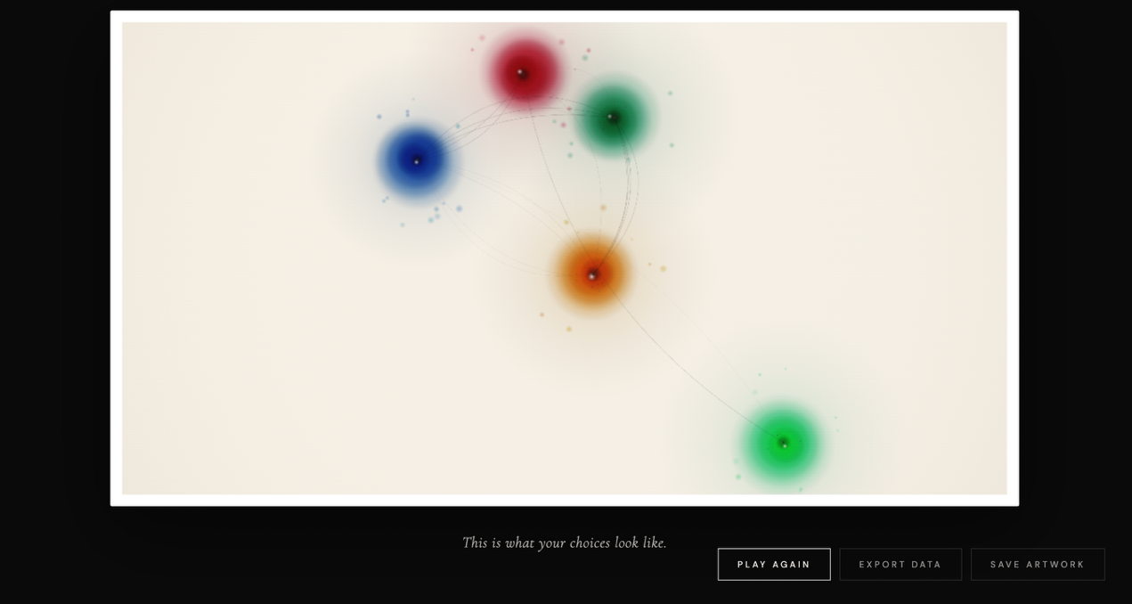

“This is what your choices look like.” The final reveal — watercolour blooms positioned and coloured by the participant’s selections, their size and saturation set by how quickly each choice was made. Every run produces a different, unrepeatable composition.

Moodboard / references:
The generative output draws on two aesthetic references: Turkish ebru (paper marbling) as its primary visual language, concentric rings with randomised offsets simulating ink bleeding on water, and the generative systems of Vera Molnár and Casey Reas for the underlying logic of accumulation and emergence.

- Diagrams
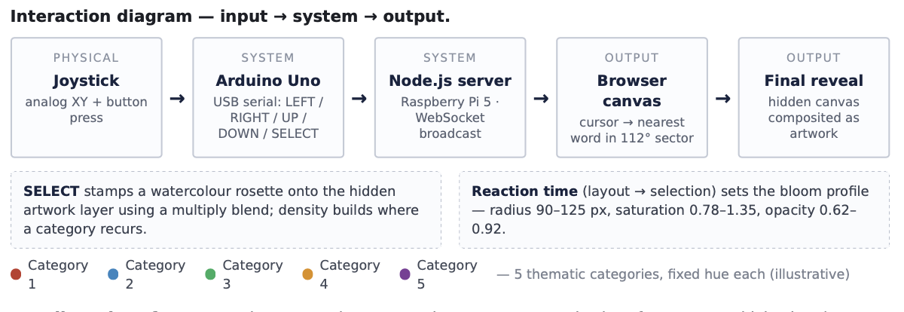
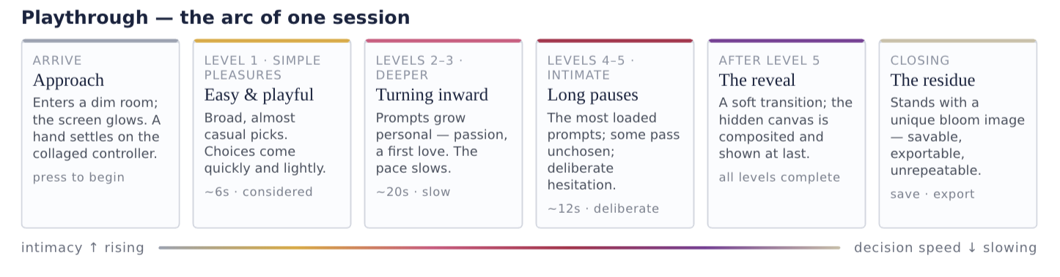
- Conclusion

You Chose This demonstrates how low-stakes, instinctive choices can be made visible as a generative self-portrait. By coupling a physical joystick, a memory-collage enclosure, real-time serial-to-WebSocket communication, and a hidden reaction-mapped canvas, the project turns the simple act of selecting a word into a record of attention: what a participant valued, and how readily they reached for it. The escalating intimacy of the vocabulary and the silent reaction-time mapping ensure that the final image reflects their instincts, while the collaged controller frames the whole interaction as a passage through remembered life.

